|  |  |
| --- | --- |
| **Project – External Document** |  |
| COMP6583  Computer Graphics |
| Odd Semester Year 2020/2021 |

* Project Title

St. Ashcre

* Introduction

The Republic of Cannorgomi is going to celebrate their 100th Independence Day within three weeks. They decided to add a glimpse one of their most iconic road—St. Ashcre—to the official government site. We are needed to make a scene using three.js

* Report / Documentation

1. Start Condition. (Third Point View)  
   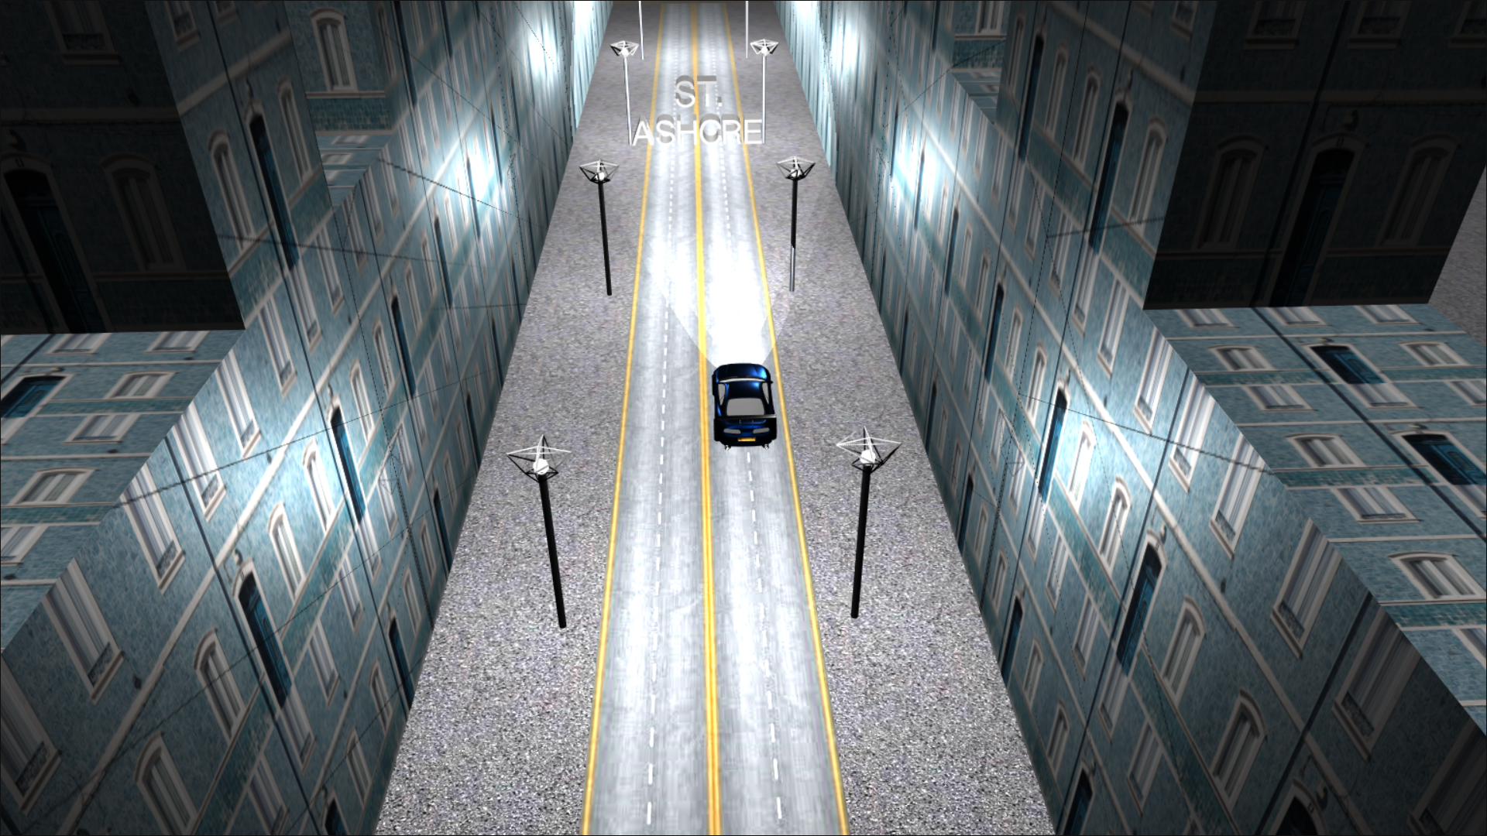  
   - All Lamp is on and you can right click the bulb on the lamp to turn off or turn on the lamp.  
   - You can move around the camera with left click on mouse.  
   - Camera will always focus to the car.  
   - You can zoom in or zoom out by scrolling middle button on mouse.  
   - You cannot go under the Asphalt and behind of the building.  
   - You can press CTRL to switch cam to Car Driver Camera
2. Car Driver View  
   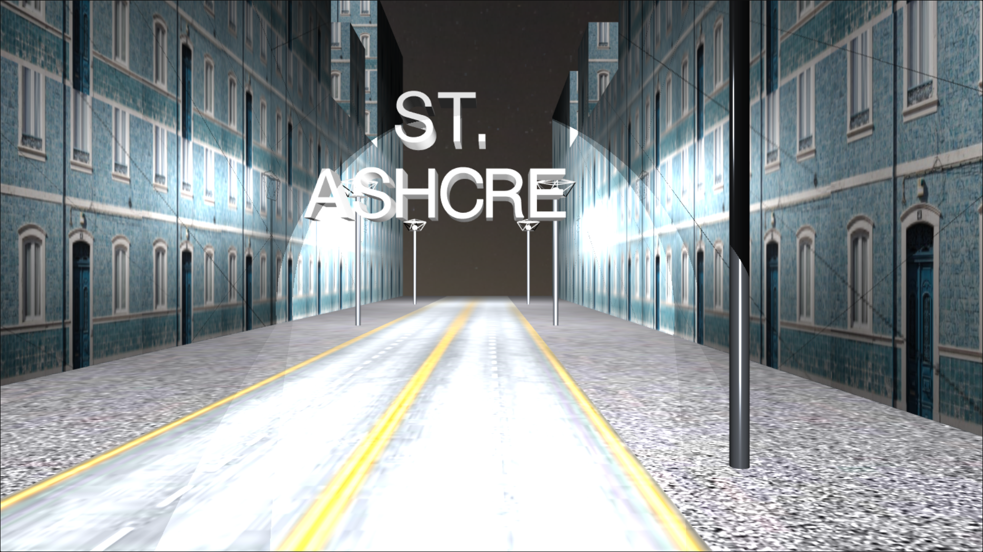  
   - You can move the car by pressing w or s.  
   - Car cannot move outside of the skybox  
   - You can right click the bulb on the lamp to turn off or turn on the lamp.
3. Turn Off the Lamp  
   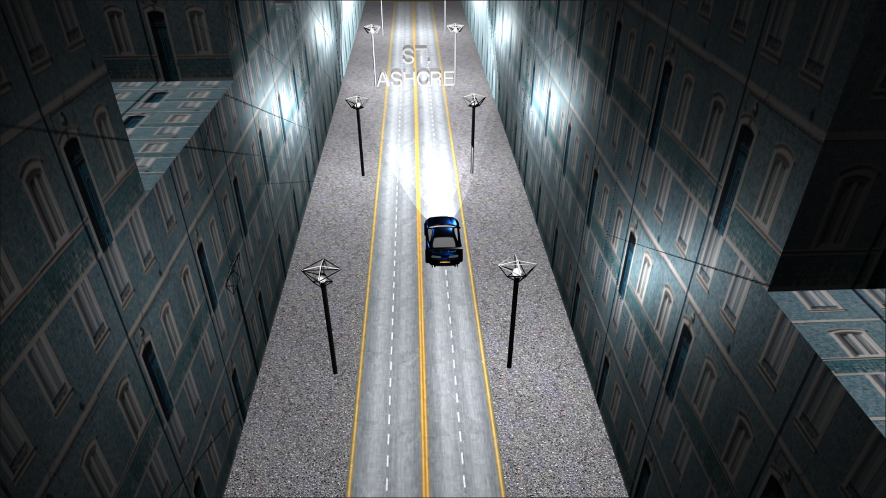
4. Moving Car  
   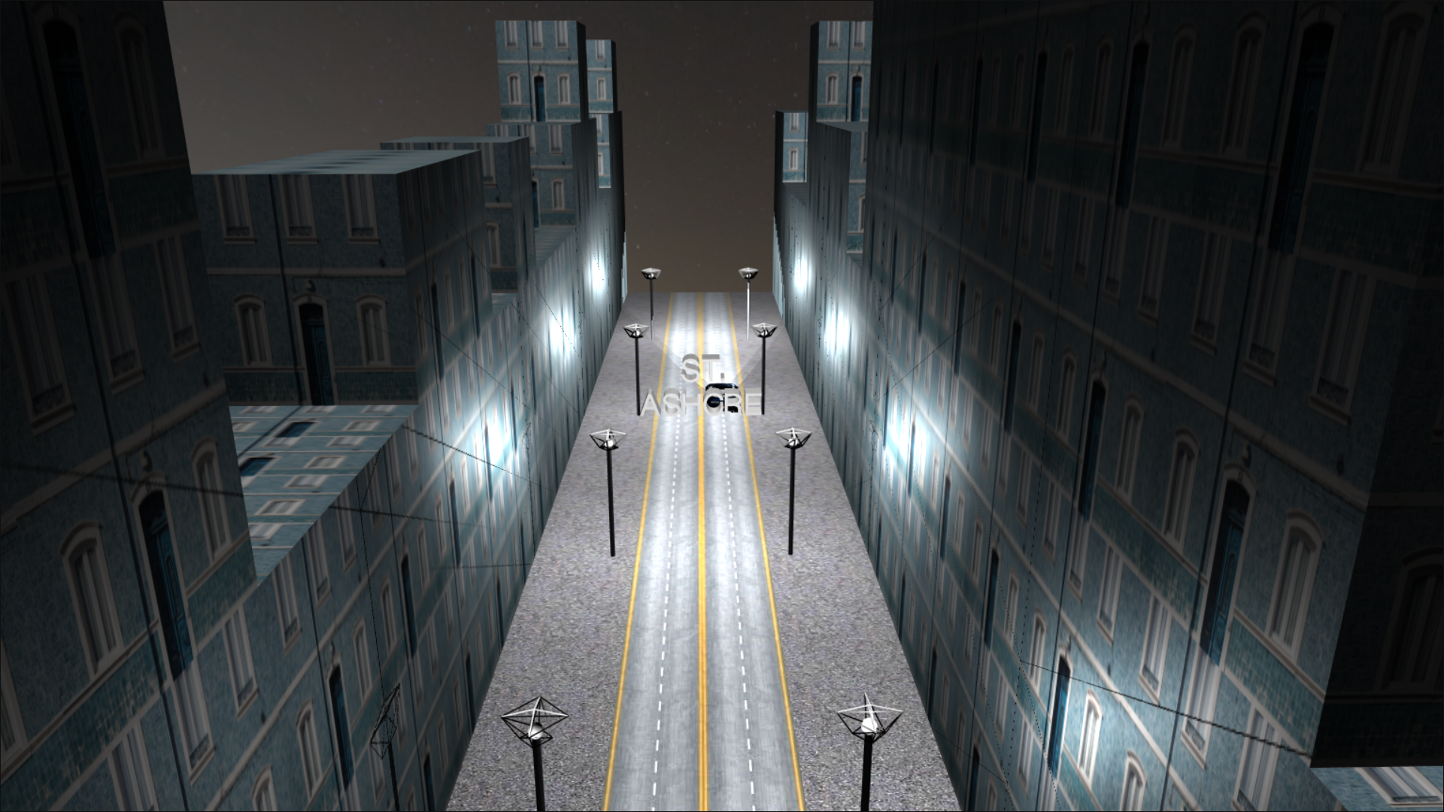  
   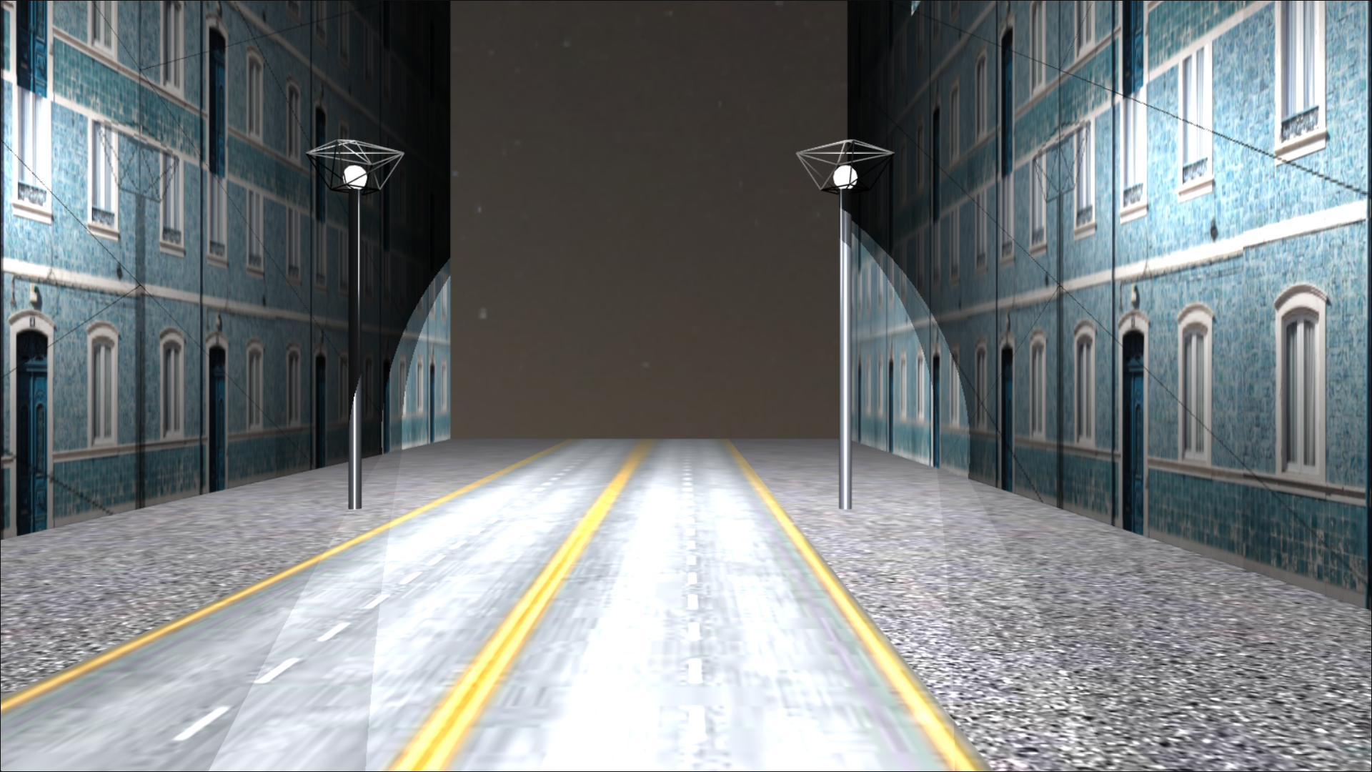

* Reference
* https://www.cgtrader.com/items/2233891/download-page
* https://hdrihaven.com/hdri/?c=skies&h=moonless_golf
* https://freestocktextures.com/texture/old-blue-facade,1121.html
* https://www.textures.com/browse/asphalt-close-ups/12430.
* https://images.megapixl.com/5644/56448654.jpg
* https://threejs.org/docs/index.html
* https://keycode.info/
* Group Member
* 2201761475 – Elton Yeo
* 2201752994 – Louis Choules
* 2201741385 – Vanessa Louise